Institute of Computer Technology

B. Tech Computer Science and Engineering

Subject: Basics of Communication Systems (2CSE202)

**PRACTICAL-EXAM**

**AIM: -**

|  |  |
| --- | --- |
|  |  |
|  | Create a wireless LAN as shown in following figure. Create wireless Access point with WEP key as your 11 digit enrollment number. Send ICMP packet from Laptop0 to PC0. Also create a MAC filter at wireless router in such a way that only laptop0 is able to connect with wireless router. |

***SOLUTION***

Configure the following devices as shown below: -

**List of devices: -**

* Router0
* Switch0
* PC0, PC1
* Wireless Router0
* Laptop0, Laptop1

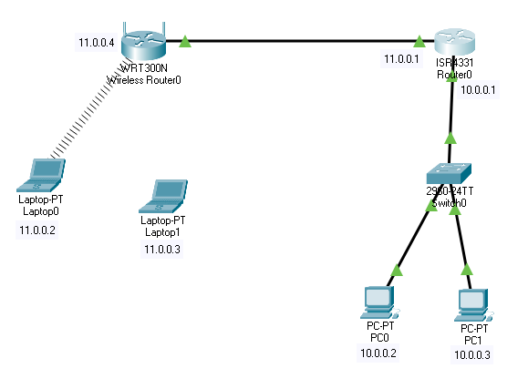

**(1) Router0: -**

Give IP address accordingly

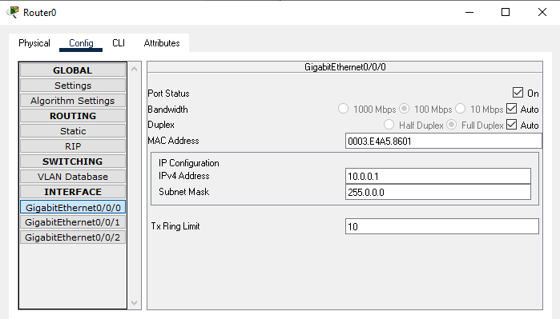

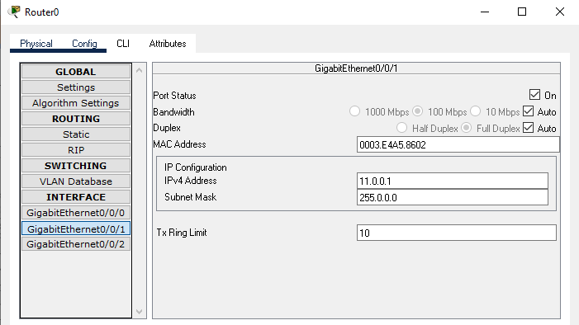

Add RIP routing in router for convinence,

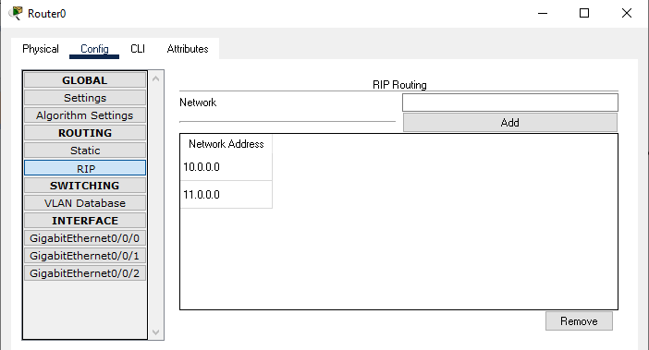

**(2) PCs: -**

**PC0**

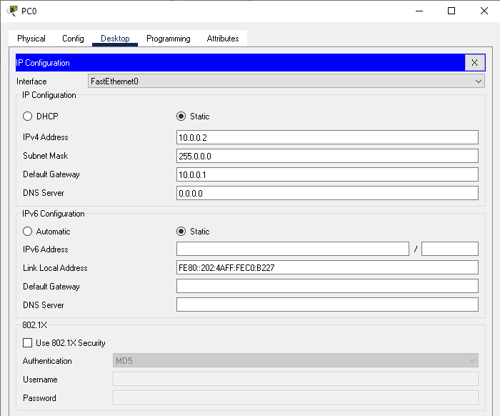

**PC1**

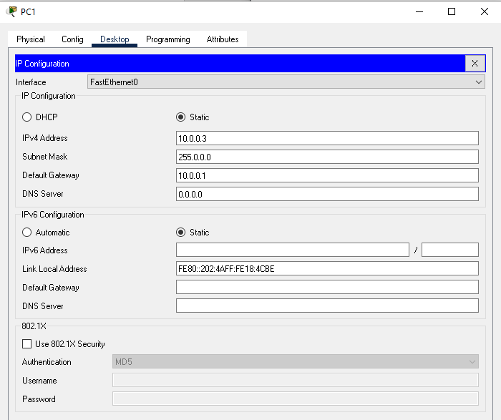

**(3)** **Wireless Router0: -**

Configure the Wireless Router0 as follows: -

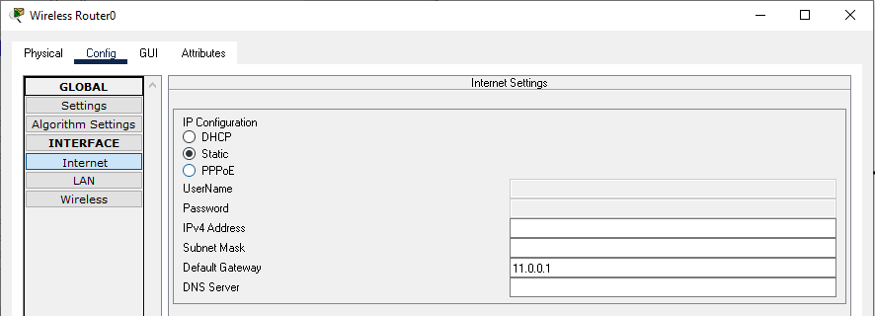

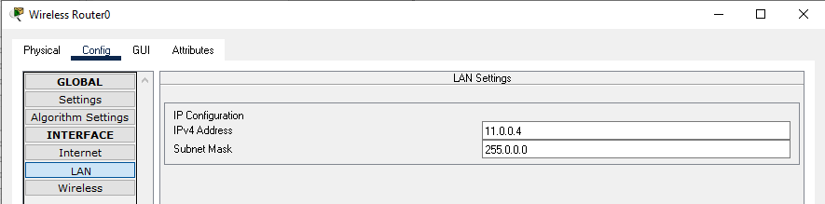

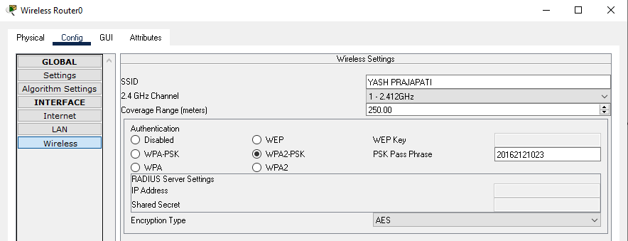

**(4) Laptops: -**

* First of all, we have to add wireless module (WPC300N) in laptops.
* For that we have to turn off laptop remove the existing hardware and add wireless module (WPC300N).

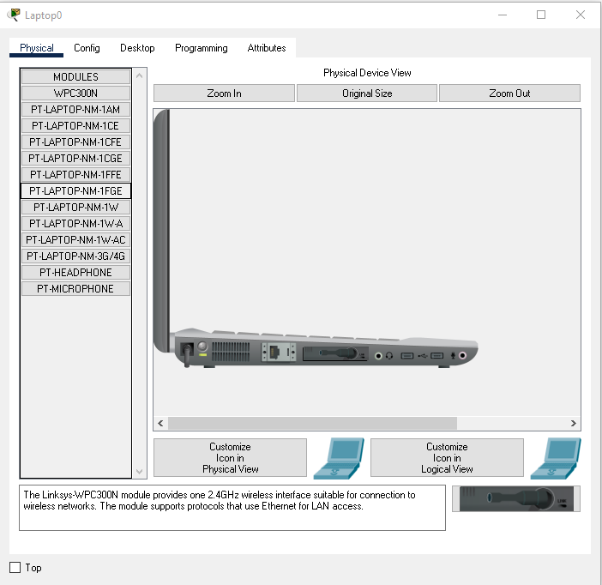

* Then we will have to add IP addresses to laptops as follows: -

**Laptop0: -**

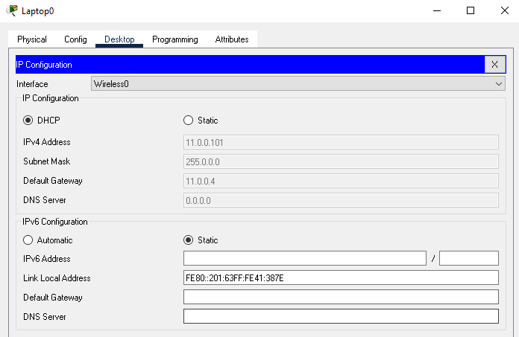

**Laptop1: -**

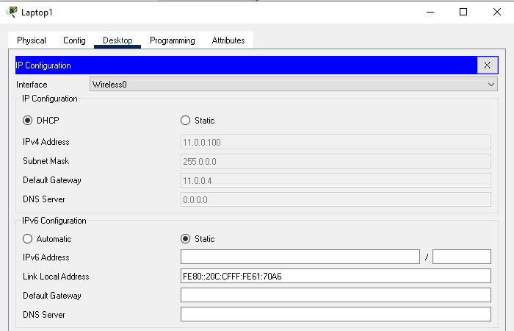

**Now for MAC filtering at wireless router**

* First we will need to see the MAC address of Laptop0

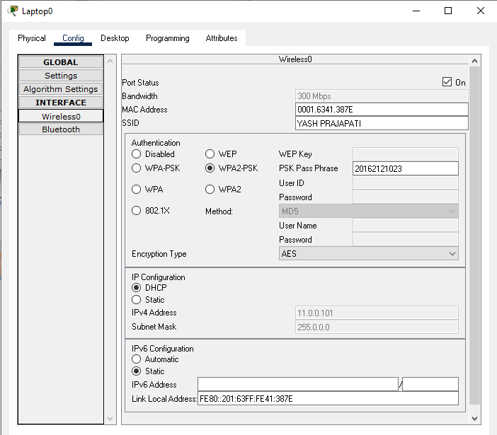

* Now goto Wireless Router0, click on “GUI”
* In GUI, goto “Wireless” and in wireless goto “Wireless MAC filter”.
* Click on enable option and click on “Permit PCs listed below to access wireless network” add the MAC address of Laptop0 in the list.

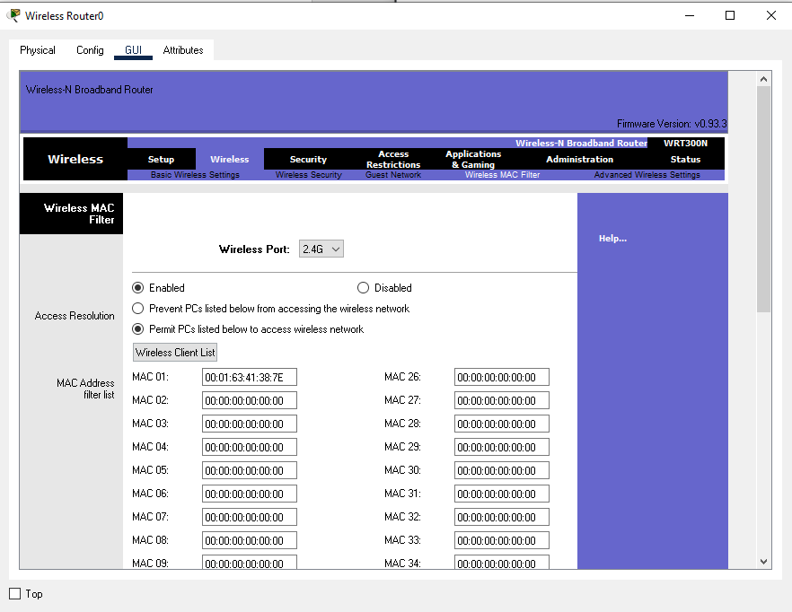

***CONCLUSION***

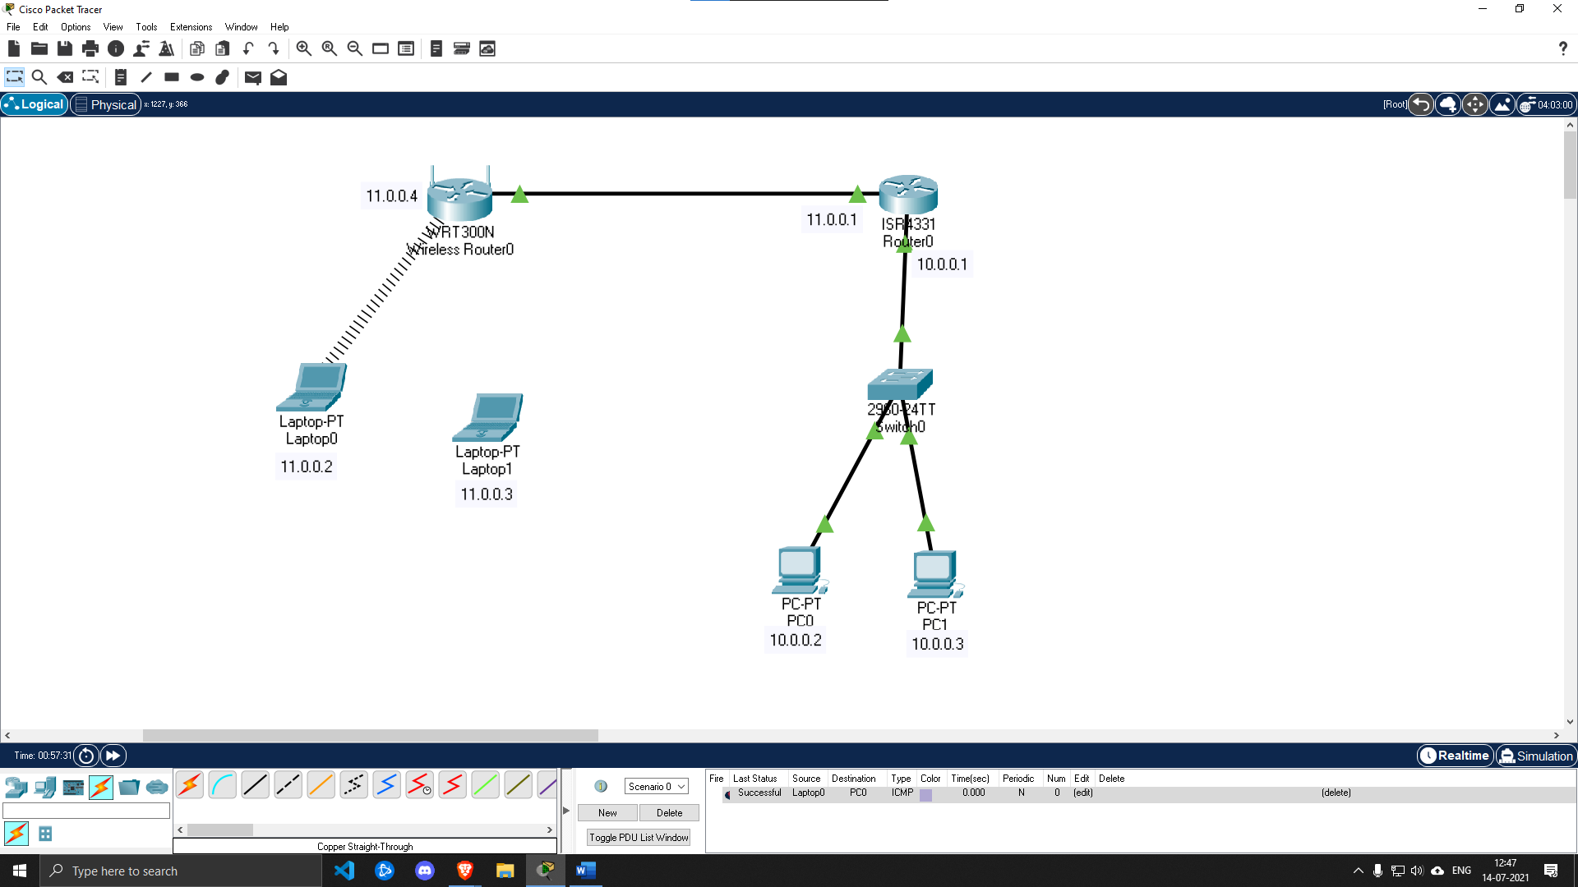



As per ques, we are now able to send ICMP packet from Laptop0 to PC0. And we also created a MAC filter at wireless router in such a way that only laptop0 is able to connect with wireless router.